**README for Java Selenium Project by James Ohia**

This project is a Java-based UI automation project using Selenium and Maven. It implements the Page Object Model (POM) design pattern for better code organization and test case maintenance. The project automates two assignments: Assignment #1 for Facebook and Assignment #2 for WalletHub.

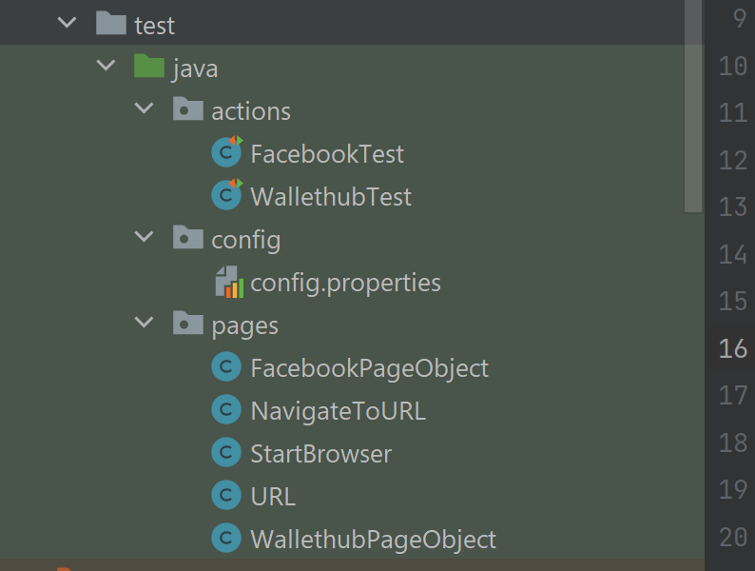

Software and Dependencies:

1. Intellij (IDE)
2. Java 8 or any other acceptable JDK and SDK
3. Web Drivers: ChromeDriver, GeckoDriver (for Firefox), and IEDriverServer (for Internet Explorer)
4. Maven for project management and dependency resolution
5. pom.xml file contains the necessary dependencies, such as selenium-java, JUnit, and TestNG.

Project Structure:

1. The project is structured as a Maven project.
2. The drivers folder contains the required web drivers for Chrome, Firefox, and Internet Explorer.

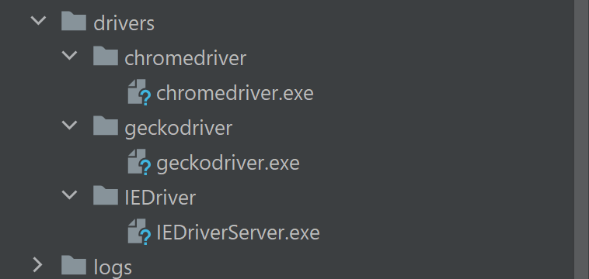

1. There are seven Java classes in total:

* URLClass: Sets up the URLs for Facebook and WalletHub.
* StartBrowserClass: Configures the web browser properties and selects the browser based on the configuration in the config.properties file (Chrome is selected by default).
* NavigateToURLClass: Navigate to the specific URLs for the tests, such as faceBookUrl() for Assignment #1 and walletHubUrl() for Assignment #2.
* FacebookPageObjectClass: Stores all the web elements related to the Facebook page task and defines the corresponding methods.
* WalletHubPageObjectClass: Stores all the web elements related to the WalletHub page task and defines the corresponding methods.
* FacebookTestClass: Executes the test cases for the Facebook page task. It uses TestNG annotations, such as @BeforeTest, @Test, and @AfterTest, for setup, execution, and cleanup tasks, respectively.
* WalletHubTestClass: Executes the test cases for the WalletHub page task. It also uses TestNG annotations for setup, execution, and cleanup tasks.

Running the Tests:

1. TestNG is used to run the tests. The configuration is specified in the testng.xml file.
2. You can run all the tests together by executing the testng.xml file.
3. Ensure that the necessary web drivers are available in the drivers' folder and that the configuration in config.properties is correctly set.

